Daniel Ackuaku

21st February 2019.

ENGR 304 Lab 2

Prof. Andrew Jo

Pseudocode for the Fibonacci sequence

initialize the variables term1 = 0, term2 = 1, nextTerm = 0, counter = 0, limit = 40.

initialize the array[limit] to hold the values

while limit < 40 {

nextTerm = term1 + term2;

store t1 into the array[counter];

term1 = term2;

term2 = nextTerm;

increment the counter by one;

}

Printout of the assembly code

/***************************************************************************/

/* Name: <Daniel Ackuaku> */

/* Course: Engineering 304L */

/* Lab: <Lab Number 2> */

/* Date: < 18th February 2019.> */

/***************************************************************************/

/* The ".include nios_macros.s" assembler directive includes NIOS macros for use in the program */

.include "nios_macros.s"

/* The word-aligned address of the reset vector, value is taken from the

cpu configuration in SOPC builder. */

/*TEMPLATE: replace 0x00 with the appropriate address */

.equ RESET_VECTOR, 0x00

/* The ".text" assemlber directive indicates the beginning of the code section of the program */

.text

/* The ".org RESET_VECTOR" assembler directive places the main routine at the reset address */

.org RESET_VECTOR

/* The ".global _start" assembler directive exports the "_start" label as an external symbol */

.global _start

/* The "_start" label identifies the program start location for the debugger */

_start:

/*******************/

/**** MAIN ****/

/*******************/

/**** init ****/

FIBONACCI_INIT:

movia gp, MyArray /* load the address of the array into the gp register */

mov r10, r0 /* clear register 10 for the sum */

addi r11, r0, 1 /* initialize register 11 to 1 */

mov r12, r0 /* clear register 12 for the sum */

mov r13, r0 /* clear register 13 for the sum */

mov r14, r0 /* clear register 14 for the sum */

addi r14, r0, 40 /* initialize register 11 to 1 */

/**** run ****/

FIBONACCI:

add r12, r10, r11 /* add term1 and term2 to nextTerm */

stw r10, 0(gp) /* store t1 into the memory */

add r10, r0, r11 /* term1 = term2 */

add r11, r0, r12 /* term2 = nextTerm */

addi gp, gp, 4 /* move the pointer 4 bytes */

addi r13,r13, 1 /* increment the counter by one */

bne r13, r14, FIBONACCI /* while counter !+ r14 (40) continue */

/**** destroy ****/

FIBONACCI_END:

br FIBONACCI_END /* infinite loop to keep program from going into the weeds */

/*******************/

/**** DATA ****/

/*******************/

/* The ".data" directive identifies the section of the program that defines global variables */

.data

/* The "MyArray" label has an address equal to the address of the first element in the

array of words immediately following the label, this program uses it as arbitrary

zero-terminated example content to sum in the main program. A ".word" array ensures each

element has 4 bytes of storage space */

MyArray:

.skip 40*4

/* The ".end" assembler directive indicates the end of the program and

all following lines are discarded */

.end

/********************************************************************************************/

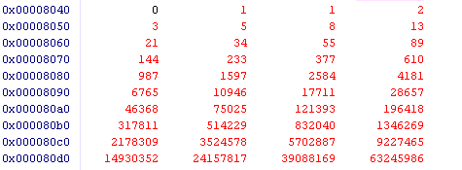

Figure 1 Results from the assembly code showing the Fibonacci sequence memory array.

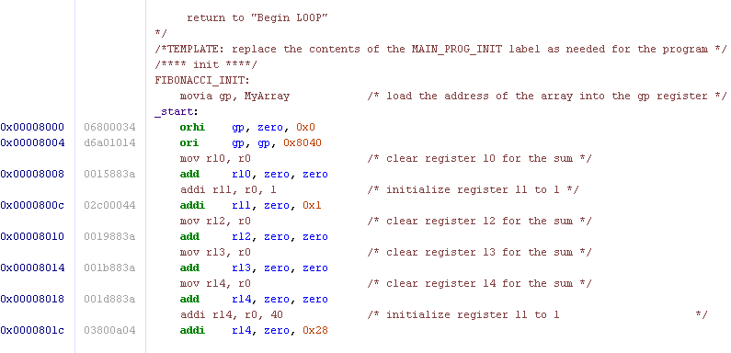

Figure 2 Debugger window of the Fibonacci Assembly code 1.

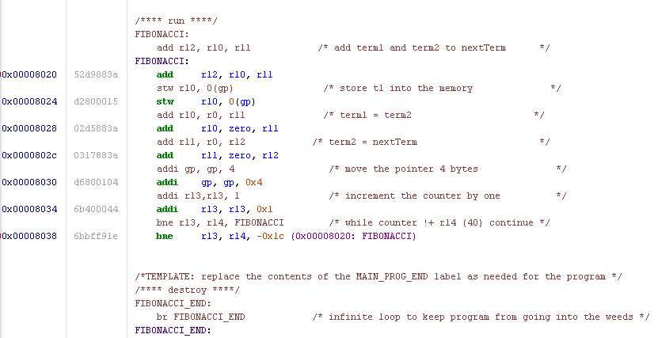

Figure 3 Debugger window of the Fibonacci Assembly code 2.

Code to calculate the first 40 terms in the Fibonacci sequence.

/***************************************************************************/

/* Name: <Daniel Ackuaku> */

/* Course: Engineering 304L */

/* Lab: <Lab Number 2> */

/* Date: <19th February 2019> */

/***************************************************************************/

/* This program calculates the first 40 numbers in the Fibonacci sequence */

int Fib[40]; /* global since declared outside main() */

int main()

{ Fib[0] = 0;

Fib[1] = 1;

int i;

for ( i = 2; i < 40; i = i+1)

{

Fib[i] = Fib[i-2] + Fib[i-1];

}

return 0;

}

/*******************************************************************************/

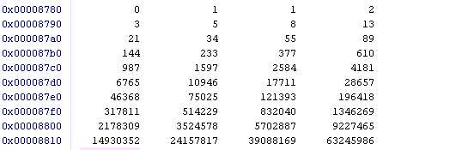

Figure 4 Results from the C code showing the Fibonacci sequence memory array.

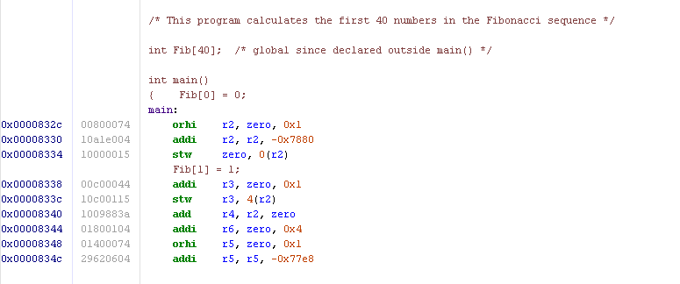

Figure 5 Debugger window of the Fibonacci main C code 1

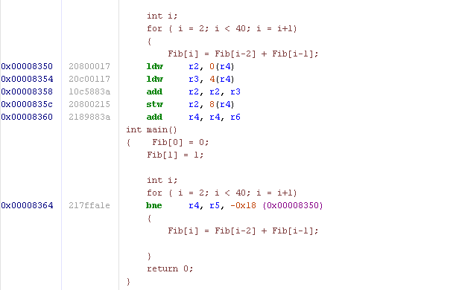

Figure 6 Debugger window of the Fibonacci main C code 2

Table showing the number of instructions executed in each version of the code.

|  |  |  |  |  |
| --- | --- | --- | --- | --- |
| Version | # non-loop instructions | # loop instructions | Total executed in the loop code | Total main function instructions executed |
| Assembly | 8 | 7 | 7 * 40 = 280 | (7 * 40) + 8 = 288 |
| -O0 | 10 | 31 | 31 * 39 = 1209 | (31 * 39) + 10 = 1219 |
| -O1 | 9 | 6 | 6 * 39 = 234 | (6 * 36) + 9 = 243 |
| -O6 | 7 | 6 | 6 * 39 = 234 | (6 * 38) + 7 = 241 |

Out of the four versions compared, the best was the version -O6. It accomplished the task with the fewest number of instructions. Version -O6 used 241 lines of code, version -O1 was not far behind with 243 lines of code, the assembly version used 288 lines of code, and the worst was version O0 with 1219 lines of code.

The C code version O1 utilized the resisters within the range r0, r2, r3, r4, and the code version O6 utilized the resisters r0 -r3, r7, r8 and the code version O0 utilized the resisters within the range r0 -r3, r7, r8 whereas the assembly code written utilized the registers r0, r10, r11, r12, r13, r14.

Versions -O1 and -O6 had a similar loop structure that consisted of two sections the first section had 5 lines of code and the second section had 1 line of code. Similar to this loop structure the assembly code also had 2 distinct sections within the loop structure, the first being 5 instructions long and the second having 2 lines of code. Version -O0 also had 2 sections however in this implementation the first section had 25 lines of code and the second section had 6 lines of code.

The handwritten assembly took 41 more instructions than the highly optimized code of version -O6.